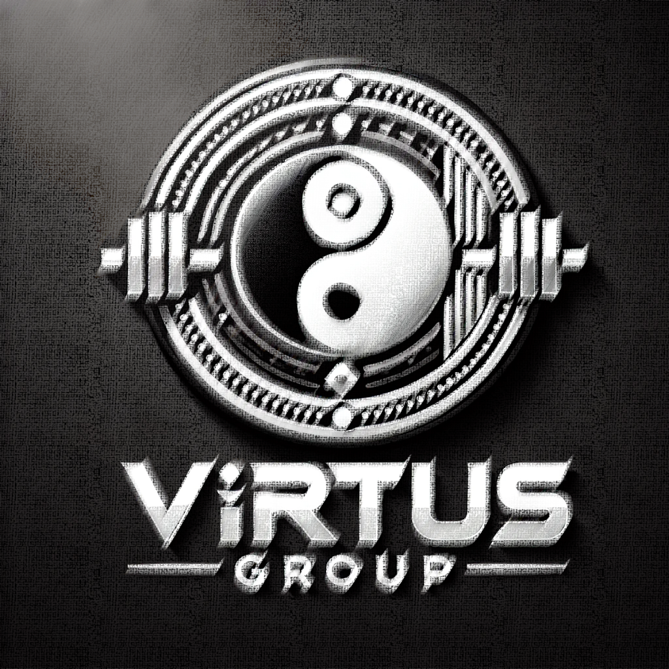

Virtus Group - Company Overview

Operational Statement
At Virtus Group, we operate with precision, purpose, and passion. Our daily commitment is to provide a dynamic, safe, and empowering fitness environment for individuals at every stage of their wellness journey. We focus on streamlined service delivery, state-of-the-art equipment, professional guidance, and an inclusive community culture.
Our operations are driven by the following core pillars:
Consistency in Service: Open 7 days a week with structured hours, our team ensures dependable, professional support and availability.
Safety First: All staff and trainers are certified, and safety protocols are regularly reviewed and reinforced across all facilities.
Tailored Programming: We deliver group classes, personal training, and wellness resources adapted to a wide range of fitness goals and lifestyles.
Community Engagement: We actively support and host community events, wellness seminars, and inclusive programming for all age groups and abilities.
Clean, Modern Spaces: We maintain clean, modern, and motivating spaces—routinely sanitized and upgraded to meet member expectations.
Virtus Group isn’t just a gym. It’s a high-performance environment built for growth—physical, mental, and social. Our day-to-day operations reflect our promise to make every member feel supported, valued, and inspired.

About Us

Who We Are
Virtus Group is more than just a gym — we are a movement. Founded on the principles of discipline, balance, and community, we provide a space where individuals from all walks of life can improve not only their physical health but their mental resilience. Our team is made up of dedicated professionals committed to guiding and supporting each member on their personal fitness journey.

Our Mission
Our mission is to empower every individual who walks through our doors — not just to train harder, but to live stronger. We believe that true fitness is about building a foundation of strength, discipline, and self-respect that carries into all aspects of life.

Our Vision
We envision a future where Virtus Group is not just a gym but a cornerstone of wellness in our community. We are working toward building new programs focused on mental health support, injury prevention, and inclusive training for all ages and abilities. We aim to expand our facilities, offer digital memberships, and launch community outreach projects that make wellness accessible to everyone.

What Drives Us
Community First: We believe fitness should be inclusive and accessible. Our diverse and supportive environment ensures everyone feels welcome and valued.
Growth Through Discipline: We promote sustainable progress through consistent effort, personal accountability, and mental toughness.
Innovation and Education: We embrace new techniques, technologies, and ideas to help our members stay informed and inspired.
Mind-Muscle Connection: Wellness isn’t just physical. We promote the integration of mind and body for true, lasting health.

Our Commitment
At Virtus Group, your goals become our goals. Whether you’re here to lose weight, gain strength, boost confidence, or simply feel better in your skin, we are here every step of the way. We’re not just building stronger bodies — we’re building better lives.

Membership Options
At Virtus Group, we offer flexible, inclusive, and high-value membership plans to support every lifestyle and fitness goal. Whether you're just beginning your journey or you're a seasoned athlete, our memberships are designed to provide exceptional value, access, and support.
- Standard Membership
Ideal for: Individuals seeking regular gym access and basic support.
Price: €40 / month
Includes: Unlimited access to gym facilities during opening hours, Use of all standard training equipment, Complimentary fitness induction session, Access to showers and lockers, Monthly progress tracking consultation, 5% discount on in-gym retail (drinks, snacks, gear)
2. Premium Membership
Ideal for: Fitness-focused individuals who want access to group classes and extras.
Price: €60 / month
Includes: Everything in Standard, plus Unlimited group fitness classes, Priority booking for events and workshops, 1 guest pass per month, Free use of premium equipment, 10% discount on retail and select training programs
3. Student Membership
Ideal for: Full-time students (must present valid ID).
Price: €30 / month
Includes: Full access to gym during student hours, Use of all training equipment, Free access to student-only fitness classes, Monthly student wellness seminars, No joining fee
4. Day Pass
Ideal for: Visitors or casual users.
Price: €10 / day
Includes: Full gym access for one day, Use of locker rooms and facilities, Free bottle of water and towel hire
5. Family Plan
Ideal for: Families or partners training together.
Price: €100 / month (up to 3 members)
Includes: All Premium benefits for each member, One shared monthly PT session, Group family fitness activities, Discounted kids programs / youth training

Terms and Conditions

1. Acceptance of Terms
By accessing or using Virtus Group's facilities, website, mobile applications, and services, you agree to comply with and be legally bound by these Terms and Conditions. If you do not agree to these terms, you should not use our services.

2. Membership Terms
Eligibility: Membership is open to individuals aged 16 or older. Minors must have parental consent.
Fees & Payments: All fees are billed monthly or annually, depending on the membership plan selected. Payments are non-refundable unless otherwise stated.
Cancellation: Members may cancel at any time with 30 days' notice. Early cancellation fees may apply depending on contract terms.
Freezes & Holds: Memberships may be paused for valid reasons such as medical issues or travel. Requests must be made in writing.
Access: Membership grants access to all standard facilities. Certain classes or services may require additional fees.

3. Use of Facilities
Health & Safety: Members must ensure they are medically fit to use gym equipment and participate in physical activities. A health questionnaire may be required.
Code of Conduct: Abusive language, harassment, or unsafe behavior will not be tolerated. Violations may lead to suspension or termination.
Personal Belongings: Virtus Group is not responsible for lost or stolen personal items. Lockers are available but are used at your own risk.
Dress Code: Proper athletic attire must be worn at all times.

4. Classes & Personal Training
Scheduling: Classes may require prior booking. Spaces are limited and subject to availability.
Cancellations: Missed classes without proper notice may incur a charge.
Trainers: Personal training sessions must be booked in advance. Sessions not canceled within 24 hours may be forfeited.

5. Digital Services
Website Use: The website and mobile apps are for informational and booking purposes. Misuse of any online features may result in restricted access.
Online Programs: Digital training content is for members only and may not be copied, shared, or distributed without permission.

6. Privacy Policy
Your privacy is important to us. Personal data is collected and processed in accordance with applicable data protection laws. Please refer to our Privacy Policy for full details.

7. Limitation of Liability
Assumption of Risk: All members assume the risk of injury related to physical exercise and use of equipment.
Indemnification: You agree to indemnify and hold harmless Virtus Group and its staff from any claims, damages, or losses arising from your participation.

8. Changes to Terms
Virtus Group reserves the right to modify these Terms & Conditions at any time. Members will be notified of significant changes.

9. Governing Law
These terms are governed by the laws of [Insert Jurisdiction]. Any disputes shall be resolved in the courts of [Insert Jurisdiction].

10. Contact Us
For any questions or concerns, please contact:
Virtus Group
Coders Coffeehouse
42 Coffeebean Street, Dublin
📞 012 345 678 910
📧 email@coderscoffeehouse.com

© 2025 Virtus Group. All rights reserved.

